BodyBoost


By:

Anosh Junaid
11359
Muhammad Ali Hamza
12826
Hidayat Ullah
11939

Supervised by:
[Mr. Muhammad Usman Karim]

Faculty of Computing
Riphah International University, Islamabad
Spring/Fall 2023
A Dissertation Submitted To

Faculty of Computing,
Riphah International University, Islamabad
As a Partial Fulfillment of the Requirement for the Award of the Degree of
Bachelors of Science in Software Engineering

Faculty of Computing
Riphah International University, Islamabad

Date: [date of final presentation]
Final Approval

This is to certify that we have read the report submitted by Anosh Junaid (Sap Id #11359), Muhammad Ali Hamza (Sap Id #12826), Hidayat Ullah (Sap Id #11939) for the partial fulfillment of the requirements for the degree of the Bachelors of Science in Computer Science (BSCS). It is our judgment that this report is of sufficient standard to warrant its acceptance by Riphah International University, Islamabad for the degree of Bachelors of Science in Computer Science (BSCS).

Committee:

1 | [Name Supervisor]  (Mr. Muhammad Usman Karim)
2 | [DR. Musharaf Ahmed]  (Head of Department/chairman)

Declaration

We hereby declare that this document “BodyBoost” neither as a whole nor as a part has been copied out from any source. It is further declared that we have done this project with the accompanied report entirely on the basis of our personal efforts, under the proficient guidance of our teachers especially our supervisor Mr. Muhammad Usman Karim. If any part of the system is proved to be copied out from any source or found to be reproduction of any project from anywhere else, we shall stand by the consequences.

___________________________
Anosh Junaid
11359

___________________________
Muhammad Ali Hamza
12826

___________________________
Hidayat Ullah
11939

Dedication
To the kindest person, Mother, and especially the dearest person, Father who was always our support and whose prayers brought us up to this level and our supervisor; the kindest
dedicated person that it would have been impossible for us to complete or accomplish our
goals of the project if he wasn’t there for us.

Acknowledgement

First of all, we are obliged to Allah Almighty the Merciful, the Beneficent and the source of all Knowledge, for granting us the courage and knowledge to complete this Project. We want to express our sincere thanks to our project supervisor Mr. Muhammad Usman Karim for his guidance. We also take this opportunity to thank our parents for the unceasing encouragement, support, attention and reassuring our confidence. We also place our sense of gratitude on record to one and all who directly or indirectly have lent their hand in this venture. Lastly, we would like to thank each other (Project Team – Anosh Junaid, Muhammad Ali Hamza and Hidayat Ullah) for caring support under challenging situations.

___________________________
Anosh Junaid
11359

___________________________
Muhammad Ali Hamza
12826

___________________________
Hidayat Ullah
11939

Abstract

The global health and fitness industry is continuously growing, with an increasing number of people looking for convenient ways to stay fit and healthy. After COVID 19
People become app oriented, they don’t want to go in gym rather they want to do exercises in home on their free time. They want to have good diet plan and do proper exercise to keep themselves fit, Problem occur when some people who aren’t mentally stable or in stress when they start eating nutrients what aren’t good for their health. Our app can tap into this expanding market Provide users with personalized workout and diet plans tailored to their emotional states, contributing to holistic well-being. By integrating social media textual data, the system captures real-time sentiments, enabling personalized workout and diet plans aligned with users' emotional states expressed.

Table of Contents
1.1 Opportunity 12
1.1.1 STAKEHOLDERS 14
1.2 Motives and Challenges 14
1.3 Goals and Objectives 15
1.4 Solution Overview 15
1.5 Report Outline 16
2 Literature review 17
2.1 Introduction 17
2.2 Background and Problem Elaboration 18
2.3 Detailed Literature Reviewer 19
2.3.1 Related research work 19
2.3.2 Existing Solutions for Daily Wage Workers 19
Literature Review Summary Table 20
3 Requirements and Design 21
3.1 Introduction: 21
3.2 Problem Scenario 22
3.3 Functional Requirements 22
3.4 Non-Functional Requirements 23
3.5 SQA Activities: Defect Detection 24
4 Chapter 4: System Design 25
5 Implementation 27
5.1 Endeavour (Team + Work + Way of Working) 27
5.1.1 BodyBoost App 27
5.1.2 Team Members 27
5.1.3 Work Breakdown Structure (WBS) 27
5.1.4 Project Schedule 28
5.1.5 Way of Working 28
5.1.6 Risk Management 29
5.2 Flow Control/Pseudo codes 30
5.2.1 Sign up Page 30
5.2.2 Login Page 31
5.3 Components, Libraries, Web Services, and Stubs 32
5.3.1 Components 32
5.3.2 Libraries 33
5.4.3 Web Services 34
5.5.4 Stubs 34
5.5 IDE, Tools and Technologies 35
5.6 Best Practices and Coding Standards 35
5.7 Deployment Environment for Body Boost 36
5.8 Summary 37

Chapter 1:
Introduction

Introduction

Opportunity

Physical activity can help people maintain a healthy weight and lower their chance of developing a variety of chronic conditions and many diseases. Despite this information, adults and children in many nations, countries do not engage in physical activity on a regular basis or any physical games. Researchers have never-before-seen chances to learn and adopt more about the health advantages of physical activity thanks to recent advancements in physical activity monitoring.
Research indicates that technology has played a role in the rise in sitting down and decline in physical activity. On the other hand, it has additionally inspired a number of creative physical activity-focused therapies.
One such innovation is through the use of mobile fitness apps and the sharing of one’s workout through a social network. This paper will focus on the collection of self-reported fitness data through a mobile fitness app that is then shared with one’s social network via Twitter. The dataset of these tweets along with other connected datasets of demographic information allows for a number of analyses, including but not limited to the potential influence of such tweets and the sentiment of these tweets. By combining the digital traces as people interact through mobile phones and emerging technology may now provide novel methods to assess a range of factors objectively and with minimal expense and burden to participants. This paper will review both the potential online influence and the sentiment of the shared fitness tweets.
The way societies have been exposed to information has changed as a result of social media like Facebook, tweeter etc. Twitter has developed into a more beneficial tool for the general population to express their opinions, ideas, and thoughts. Twitter is one of the most used application worldwide. It is a free social networking site that is utilized by both people and companies to share their ideas and business.

The mission of Twitter is to “give everyone the power to create and share ideas and information instantly, without barriers”. With 328 million active monthly users, more than 1 billion unique visitors each month to sites with embedded tweets. Twitter users can rapidly and directly share with and respond to a massive audience, using messages of 140 characters or less. With the creation and introduction of newly developing technologies such as Twitter, new opportunities to obtain global health data that may circumvent the limitations of traditional data sources used in population health and physical activity research are now available.

Health and Fitness Industry Growth: The global health and fitness industry is continuously growing, with an increasing number of people looking for convenient ways to stay fit and healthy. our app can tap into this expanding market.
Community Building: Creating a supportive community within the app can foster engagement and retention. Users can motivate each other, share progress, and seek advice.
Data Analytics and Insights: Providing users with detailed analytics on their progress, along with suggestions for improvement, can set your app apart from others.
Monetization Options: Explore various monetization models, in-app or partnerships with fitness equipment or nutrition brands.

STAKEHOLDERS

- End Users:
  - The individuals who will use the app to improve their fitness and overall health.
- Fitness Trainers and Instructors:
- our app involves expert advice or personalized training plans, fitness professionals become stakeholders. They may provide content or expertise for the app.

Motives and Challenges

The main motive in our mind is to develop a fitness app so that it will facilitate user and nutritionist both. Our App will provide users with personalized workout and diet plans tailored to their emotional states, contributing to holistic well-being. To give good diet and exercise but looking at his mental state, the detection will be performed using Machine learning models.

In our fast-paced lives, we often struggle to stay healthy while dealing with different emotions like stress or happiness. The problem is current fitness apps don't really understand our feelings. They give us the same exercises and diet plans, no matter how we're feeling. This disconnect means we miss out on personalized advice that matches our emotions. The motivation for a new solution is clear. We need a smart system that understands our feelings in real-time. Using this system, we can create personalized workouts and diets that match our feelings, making it much easier to stay healthy and happy.

Goals and Objectives

We want to create a smart system that understands how you're feeling, like if you're stressed or happy. Our fitness app's objectives include encouraging overall wellbeing through the integration of sentiment analysis and BMI calculations for an integrated strategy to health. Our goal is to customize fitness experiences by making nutrition and exercise suggestions based on individual body metrics and social media-derived emotional states. Our goals are to: apply precise BMI computations; incorporate a dependable sentiment analysis module; create an adaptive recommendation engine; guarantee user-friendly profile management; give app security and privacy first priority; create mechanisms for continuous improvement; and develop a pleasant and easy-to-use user experience. By implementing these aims and objectives, we hope to provide a motivating and encouraging fitness platform that takes into factors related to mental and physical health and fosters long-term user engagement.

Solution Overview

Introduction: Our app can tap into this expanding market Provide users with personalized workout and diet plans tailored to their emotional states, contributing to holistic well-being. By integrating social media textual data, the system captures real-time sentiments, enabling personalized workout and diet plans aligned with users' emotional states expressed.
Conclusion

We want to create a smart system that understands how you're feeling, like if you're stressed or happy. This system will use that info to give you personalized workout and diet plans. It's similar to having a fitness buddy fitness partner. It will be easy to use and understand, so you won't need to be a mobile application expert and genius. Our goal is to help you manage your physical and mental state, deal with your emotions, and find your path to health and fitness. We want to convert the way you manage your health by customizing your fitness journey to fit your specific needs and emotional state. The goal is to grow a happier, healthier version of yourself by making good food and training choices every step of the way.

Report Outline

Our project involves the implementation of a fitness app through sentiment analysis algorithms. It will process user-input sentiments, extracting emotional cues such as stress or happiness, forming the foundation for personalized recommendations. The Data will be Collected gather from user-input data, which may include text-based input or responses to emotion-related prompts. This could be collected directly within the application or through integrated social media platforms.

Chapter 2:
Literature / Market Survey

Literature review

Introduction

In this chapter, we have discussed our background and problem elaboration in detail. In detailed literature review, we have mentioned that how previous studies showed that a variety of researchers from across the globe are working on sentimental analysis and health and fitness. Our focus is around the intersection of emotional assessment, fitness, and nutrition. Through a comprehensive literature review, we find research has been conducted on sentiment analysis in health-related forums and social media platforms. Studies explore how sentiment analysis can be applied to understand user emotions and attitudes towards health issues, the literature on personalized fitness applications has focused on algorithms for tailoring workout plans based on user characteristics such as fitness level, preferences, and goals. Existing fitness applications often provide generic workout and diet plans, lacking the finesse of tailoring recommendations based on users' emotional states. Our research seeks to bridge this gap by integrating sentiment analysis algorithms to discern users' emotional states and preferences, subsequently offering bespoke workout routines and dietary guidance. We have also explained existing apps that can facilitate user regarding their health issues and fitness goals i.e. (Nike training club, MyFitnessPal) and how they work.

Background and Problem Elaboration

In today's world, lots of people want personalized fitness help from their phones. But the apps we have now mostly miss out on understanding how our feelings affect our health choices. Our project, it wants to create a new kind of app that listens to your emotions and gives you fitness and diet plans that really fit you. With everyone using smartphones, this is the perfect time to make an app that really understands how we feel about our health.
The problem is, the current fitness apps are a bit basic. They give everyone the same exercises and diets, ignoring that we all feel different. This one-size-fits-all method doesn’t work for everyone. Our research shows that there's no app that truly gets how person feelings, our ups and downs, affect our health choices. We want to make an app that not only knows the exercises and foods you need but also understands how you feel, making your health journey more personal and enjoyable. The app which uses social media post like tweets to detect mental state. Through our project, we aim to fill this gap and make a fitness and nutrition app that's as unique as you are.

Detailed Literature Reviewer

Related research work

Previous studies showed that a variety of researchers from across the globe are working on sentimental analysis, health and fitness but very little work has been done on fitness app which takes user mental health and suggest workout plan and diet.

Existing Solutions for Daily Wage Workers

Several existing mobile applications and platforms address the needs of daily wage workers. Some notable examples include:

- FitBit: Offers activity tracking and give exercise and calculate the mass of our body.
- MyFitnessPall: Provides a similar service with comprehensive meal tracking and dedicated workout.
- Nike Training Club: Gives customized workout plans.
- 7 Minute Workout: Gives a quick and focused workout.

Strengths:
- These application gives a wide ranges of trackers that monitors various activities.
- Some of the apps provides valuable insights into user and helping them make informed choices.
- App often include variety of workouts and catering to different fitness level.
Weaknesses:
- Users find this app difficult to use, especially new member.
- Some advance features behind a premium feature, which may deter budget conscious user.
- Lack of information of the user mental health lead it to the lack of wellbeing of the user.

Literature Review Summary Table

No. | Author Name | Language | Year | Machine Learning Methods | Data Description | Performance
1. | Facebook AL | English | 2019 | RoBERTa and BERT | 160GB of text | SQuAD 94.6/89.4, 88.5 on the GLUE benchmark
2. | Muhammet Sinan Başarslan, Fatih Kayaalp | English | 2020 | NB, SVM & ANN | English | 0.85 score
3. | Sunir Gohil, Sabine Vuik and Ara Darzi | English | 2018 | SVM , SVM,NB & k-NN | 4500 Twitter records were used | 82% accuracy

Chapter 3:
Requirement Engineering

Requirements and Design

Introduction:

In this chapter we have developed our functional requirements for our actors i.e. (user, admin and nutritionist). We have also developed functional requirements here we discuss those factors which may not be direct features of our designed system but are important to consider during our system’s development. We purposed our methodology in which we aim to develop a fitness app that will facilitate the user, main motive in our mind is to develop a fitness app so that it will facilitate user and nutritionist both. Our App will provide users with personalized workout and diet plans tailored to their emotional states, contributing to holistic well-being. To give good diet and exercise but looking at his mental state, the detection will be performed using Machine learning models.

Problem Scenario
This section describes the various situations where both users and daily wage workers will utilize the app and website. This includes:
- User registration and login: How users create accounts and access the system.
- Daily Exercise: How user do his daily workout and saw his record.
- Suggesting Diet: How users find his daily diet and what nutrients should he take on what basis.
- Sentiment: How the use is feeling, what is his mental health.
- Admin dashboard for user management and data analysis: How admins manage user accounts, monitor activity, and analyze data for insights.
Blocking/unblocking users: How admins manage user access and prevent misuse.

Functional Requirements

- USER

ID | Requirements
FR 1.1 | User shall be able to register an account.
FR 1.2 | User shall be able to login to their account through authentication.
FR 1.3 | User shall be able to view his activity.
FR 1.4 | User shall be able to view his profile.
FR 1.5 | User shall be able to edit his profile.
FR 1.6 | User shall be able to forget password.
FR 1.7 | User shall be able to recover password.

- ADMIN

ID | Requirements
FR 2.1 | Admin shall be able to login to their account.
FR 2.2 | Admin shall be able to view his profile.
FR 2.3 | Admin shall be able to update his profile.
FR 2.4 | Admin shall be able manage user.
FR 2.5 | Admin shall be able to create announcements.
FR 2.6 | Admin shall be able to edit announcements.
FR 2.7 | Admin shall be able to delete announcements.
FR 3.1 | A classification module shall be able to classify the mood of the user before giving exercise.
FR 3.2 | A classification module shall be able to classify the mood of the user before giving diet plan.

Non-Functional Requirements

Non-functional requirements are the capabilities, constraints and specifications which help enhance the system and its usage. Unlike functional requirements here we discuss those factors which may not be direct features of our designed system but are important to consider during our system’s development.

- User Privacy: The system should ensure the privacy of users and their data.
- Data Security: The system should protect sensitive user data from unauthorized access.
- Accuracy: The system should accurately the mood sentiments.
- Speed: The system should process data in real-time to quickly detect mood of the user.
- Language Support: The system will support the use of English and Roman Urdu to detect the mood of the user.
- Interoperability: The system should be compatible with web browsers.

SQA Activities: Defect Detection
Software Quality Assurance (SQA) ensures the app and website meet defined requirements. This includes various defect detection activities:
- Test case design: Write comprehensive test cases that cover all functionalities and identify potential defects in code and functionality.
- Code review: Analyze the code for errors, adherence to coding standards, and potential security vulnerabilities.
- Unit testing: Test individual modules of the code to ensure they function correctly in isolation.
- Integration testing: Test how different components of the system work together and identify any integration issues.
- System testing: Test the complete system to verify it meets all specified requirements and functions as intended.
- Performance testing: Evaluate the system's performance under load and identify potential bottlenecks

Chapter 4: System Design
4.1 Introduction
4.2 Architectural Design
4.3 Detailed Design
4.4 SQA activities: Defect Detection
4.4.1 Test Case Design

Chapter 5:

Implementation

Implementation
  - Endeavour (Team + Work + Way of Working)
    - BodyBoost App:
An app for workout and diet which uses sentimental analysis

Team Members

Anosh Junaid (ID: 11359)
Muhammad Ali Hamza (ID: 12826)
Hidayat Ullah (ID: 11939)

Work Breakdown Structure (WBS)

      - Phase 1: Application Front-End Development

Task 1: Log in & sign up page
Subtask: Storing user ID in Mongo Database

Task 2: Deployment of different pages of front-end

Subtask: Selecting a easy interface for user
Subtask: Storing Images in MongoDB Database

      - Phase 2: Back-end sentimental analysis

Task 3: Integration with Social media
Subtask: Applying Twitter API for user data
Subtask: Applying Facebook API for user data

Task 4: Model Training for sentimental analysis

Subtask: Training Model with data set
Subtask: Google Colab integration for model enhancement

Task 5: Applying Facebook AL Pre-Trained model

Subtask: Collecting and analyzing data set

Project Schedule

      - Milestone 1: Application Front-End Development

Start Date: [Date]
End Date: [Date]
      - Milestone 2: Deployment of different pages of front-end

Start Date: []
End Date: [Date]

Way of Working

Agile Methodology
- Overview of Agile Principles Applied
- Iterative Development Cycles
- Regular Team Reviews and Adjustments
- Sprint Durations, Planning Meetings, and Retrospective Sessions

Collaboration Tools

Used Tools: GitHub for Document and Data Sharing, Google Drive for Collaborative Document Editing

Risk Management

      - Risk 1: Technical Challenges

Mitigation Plan: Regular Team Training Sessions
Contingency Measures: External Expertise Consultation’

      - Risk 2: Resource Constraints

Mitigation Plan: Cross-training Team Members
Contingency Measures: Resource Reallocation

Additional Features:

Offline Alerts: Implementing offline alerts for immediate notifications to farmers.
Stakeholders: The primary focus is our End user(trainee), ensuring user-friendly features and effective solutions.

Flow Control/Pseudo codes

Sign up Page

initialize controllers: username, email, phone, password
displaySignUpPage():
show Screen with Logo, Username, Email, Phone, Password fields, and Sign Up button

onSignUpButtonPress():
if validateInputs(username, email, phone, password):
executeSignUp(username, email, phone, password)
else:
displayErrorMessage("Invalid inputs")

validateInputs(username, email, phone, password):
return true if inputs are valid, else false

executeSignUp(username, email, phone, password):
createNewUser locally
sendSignUpRequestToServer
navigateToHomePage

displayErrorMessage(message):
show Error Message

createNewUser(username, email, phone, password):
// Local user creation logic

sendSignUpRequestToServer(username, email, phone, password):
// Send user details to the server

navigateToHomePage():
show Home Page

Login Page
# Initialize user input controllers
initialize controllers: username, password

# Display the login page
displayLoginPage():
show Screen with:
- Logo
- Username input field
- Password input field (masked)
- Login button

# Handle Login button press
onLoginButtonPress():
if validateInputs(username, password):
executeLogin(username, password)
else:
displayErrorMessage("Invalid credentials. Please check and try again.")

# Validate user inputs
validateInputs(username, password):
if any input is empty or invalid:
return false
else:
return true

# Execute login logic
executeLogin(username, password):
if authenticateUser(username, password):
navigateToHomePage()
else:
displayErrorMessage("Authentication failed. Please try again.")

# Authenticate user
authenticateUser(username, password):
# Logic to check username and password against stored credentials or server

# Display error message
displayErrorMessage(message):
show Error Message on Screen

# Navigate to the home page after successful login
navigateToHomePage():
show Home Page

Components, Libraries, Web Services, and Stubs

Components

Naive bayes
Description: For sentimental analysis
Functionality: Implements Naïve bayes for Mood detection of the user.
Implementation: Python

Fine-tuned Roberto Model
Description: For sentimental analysis
Functionality: Implements Roberto model for Mood detection of the user.
Implementation: Python

Google Colab
Description: Model training for Naïve bayes, fine-tune Robert0 model & tweeter integration.
Functionality: Jupyter Notebook Service Implementation: Python.

Flutter Application
Description: Front & Back-End of the Mobile application.
Functionality: Easily interface for user
Implementation: Flutter SDK.

Libraries

Tweepy

Description: Library to access Twitter Api
Integration: integration with Roberto model

Pandas

Description: For data analyzing in Colab
Integration: Used for Model training in Naïve bye

Sklearn

Description: For features classification in Colab
Integration: Used for Model training in Naïve bye

Flutter SDK

Description: Cross-platform app development kit.
Integration: Utilized for Flutter app.

Web Services

Post man
Description: It is an API platform for building and using APIs.
Integration: It is use to test different APIs .
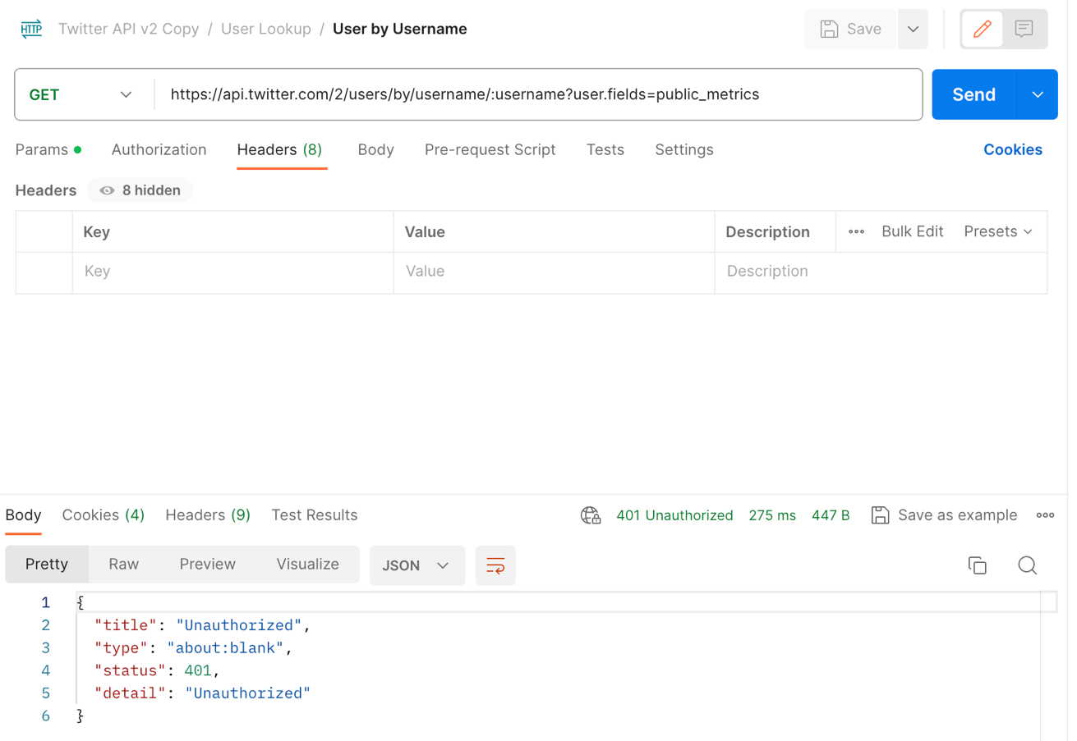
Figure ‎5.1 Testing twitter api in Post Man

Scrapper API
Description: It is use for web scrapping to get data
Integration: It is use to get the user data from social media through web.

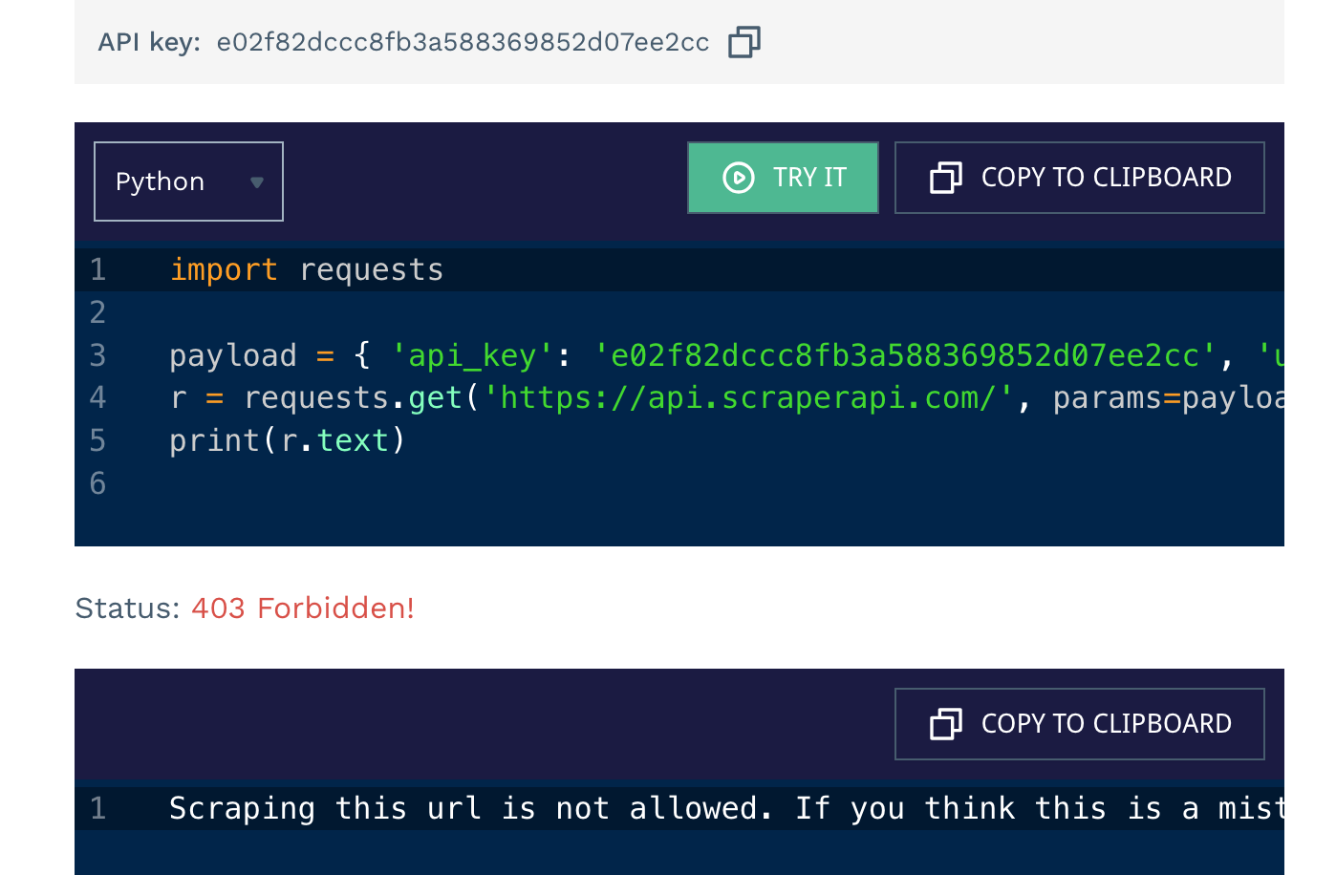
Figure ‎5.2 shows that we are unable to enter twitter URL

Twitter API
Description: For getting user data from in form of tweets
Implementation: implemented in Colab

MongoDB Database
Description: Storing user ID
Integration: Utilizes MongoDB.

Stubs

Testing Stubs

Description: Simulates external components for testing.
Usage: Validates component functionality.

IDE, Tools and Technologies

Optimized Technology Stack for Tomato Care Application

Integrated Development Environment (IDE):

Backend: Python (Specifically for Backend Development)
Flutter: Android studio Code
Collaborative Model Training: Google Colab

      - Tools:

Version Control and Document Sharing: GitHub
Containerization: Not Applicable (Omitted Docker for simplicity)

      - Technologies:

Backend: Python (Specifically for Backend Development)
Framework: Colab (Backend Web Framework)
Machine Learning: Transformers library, Auto Tokenizer
Database: MongoDB
Flutter: Dart

Best Practices and Coding Standards

Software Engineering Practices

Version Control: GitHub
Continuous Integration and Deployment Practices

Development Practices and Standards

Python Coding Standards: Adherence to PEP 8
Flutter: Followed Flutter's Coding Standards

Deployment Environment for Body Boost
    - Deployment Environment:
      - Operating System: Not Specified (Omitted AWS EC2
instances for simplicity)
      - Server Configuration:
Not Specified (Omitted specific server configuration for simplicity)
      - Database:
MongoDB

Summary
In this chapter, we outlined the composition of our project team, the detailed work breakdown structure for the implementation phase, and the methodologies and tools adopted for efficient collaboration. We addressed potential risks and mitigation strategies, presented flow control or pseudo codes, listed key components and technologies, and detailed the deployment environment. Our team adhered to best practices and coding standards throughout the implementation, ensuring a robust and effective solution.

Reference and Bibliography

[1] M. Sher, M. Rehman, “Title of the Paper” Conference name/Journal Name, Edition, Volume, Issue, ISBN/ISSN, PP, Publisher/City-Country, Year.
[2] ……

*
Appendix A:
Heading (20-Point Size, Times New Roman, Bold)

Text in 12-Point Size, Times New Roman, 1.5 Line Spacing.

  - First Level heading [14-Point Size, Times New Roman, Bold and left aligned

Text in 12-Point Size, Times New Roman, 1.5 Line Spacing.

1.1.1 Second level heading [12-Point Size, Times New Roman, Bold and left aligned]

Text in 12-Point Size, Times New Roman, 1.5 Line Spacing.

